Activity 3
5. ArithmeticException – Student Calculator
Problem Statement:
Develop a Java program to calculate the average marks of students. The program should accept the total marks and the number of subjects from the user. If the number of subjects entered is 0, the program should handle the exception gracefully and display an appropriate error message instead of terminating abruptly.
Requirements:
- Read total marks and number of subjects.
- Calculate and display the average.
- Handle ArithmeticException using try-catch.
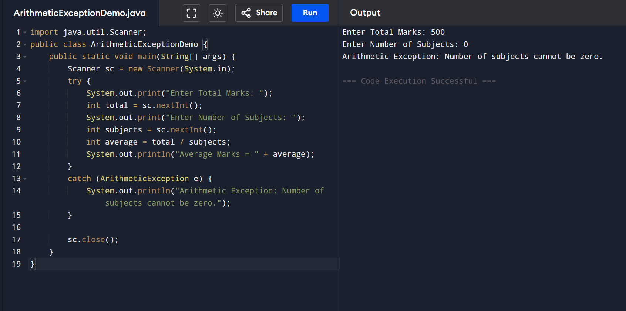
- Display a user-friendly error message when division by zero occurs.

6. NullPointerException – Employee Management System
Problem Statement:
Develop a Java program for an Employee Management System. The program should create an employee object and display the employee's name. Demonstrate a situation where the employee object is not initialized (null) and handle the resulting exception gracefully.
Requirements:
- Create an Employee class with employee ID and name.
- Attempt to access the employee object's data without creating the object.
- Handle NullPointerException using try-catch.
- Display an appropriate message instead of allowing the program to crash.
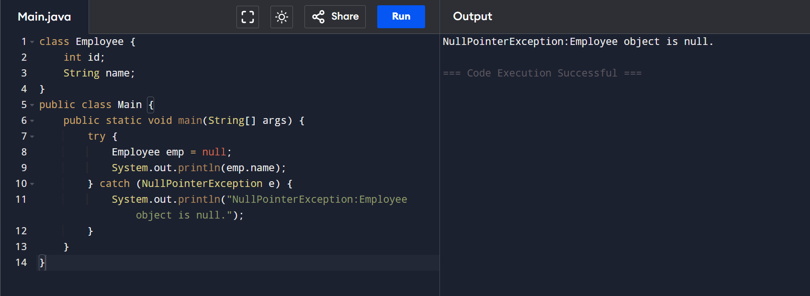

7. ArrayIndexOutOfBoundsException – Student Marks Processing
Problem Statement:
Develop a Java program to store the marks of five students in an array. Allow the user to enter the index of the student whose mark should be displayed. If the entered index is outside the valid range, handle the exception and display an informative message.
Requirements:
- Store marks in an integer array of size 5.
- Accept an index from the user.
- Display the mark corresponding to the entered index.
- Handle ArrayIndexOutOfBoundsException using try-catch.
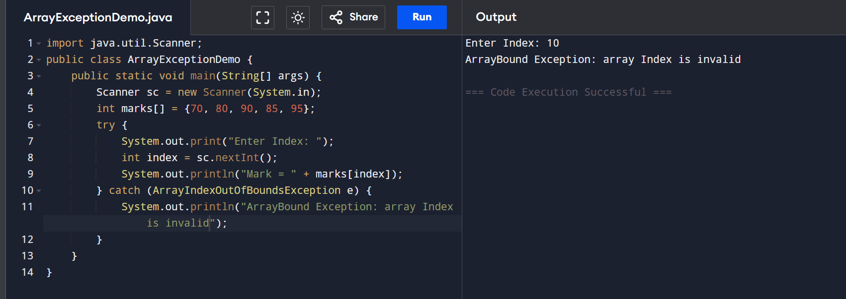
- Inform the user about the valid index range.

8. NumberFormatException – Customer Registration System
Problem Statement:
Develop a Java program for a Customer Registration System. The program should accept the customer's age as a String and convert it into an integer. If the user enters invalid data (such as alphabets or special characters), the program should handle the exception and display an appropriate error message.
Requirements:
- Read age as a String.
- Convert the String into an integer using Integer.parseInt().
- Display the customer's age if the input is valid.
- Handle NumberFormatException using try-catch.
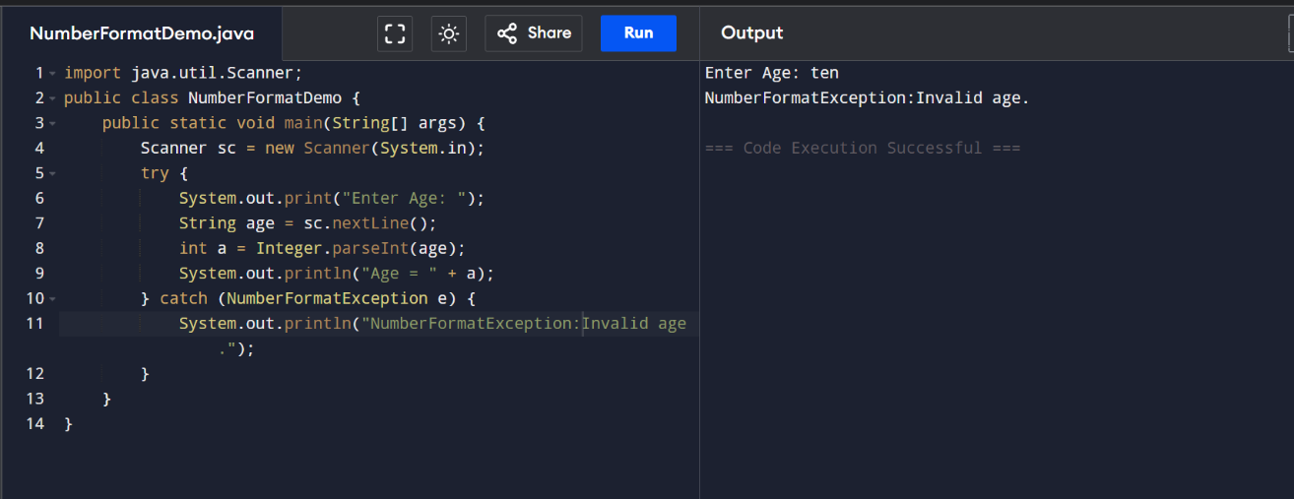
- Display a meaningful message when invalid input is entered.

1.Scenario arithmetic Exception
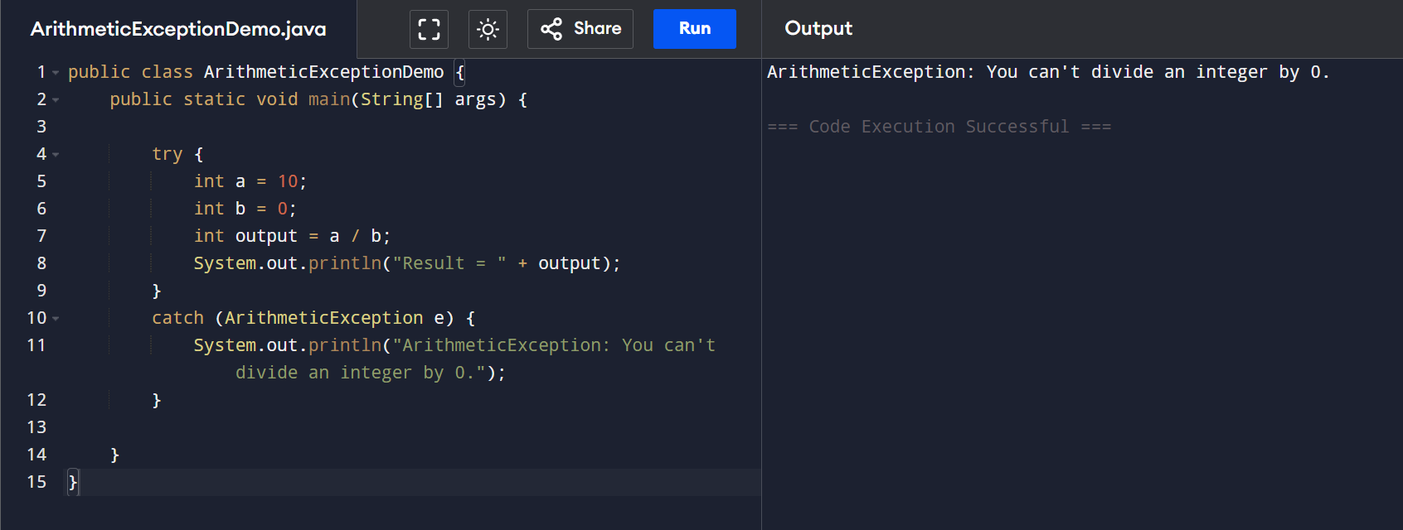
2.Scenario: Null Pointer Exception
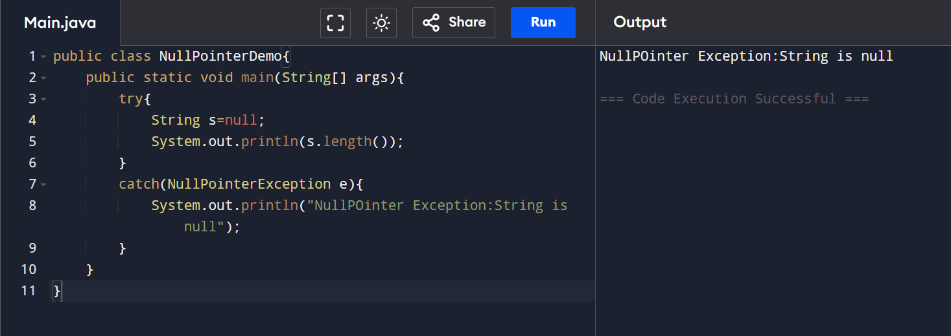
3.Scenario: NumberFormat Exception
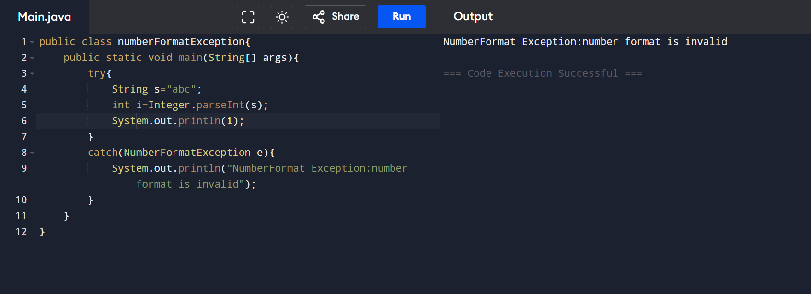

4. Scenario: ArrayOutOfBound Exception
